**Instructions**

Storyboarding is the most important thing you can do up front as part of the planning process to reduce iterations down the road and create better targeted materials. A storyboard is a visual outline of your content, created in a low-tech manner (before you create any actual content). A preferred tool for storyboarding is a stack of sticky notes, which are both small—forcing us to be concise in our ideas—and lend themselves to being easily rearranged to explore different narrative flows. I typically storyboard in three distinct steps: brainstorming, editing, and seeking and incorporating feedback.

Storyboard Example.

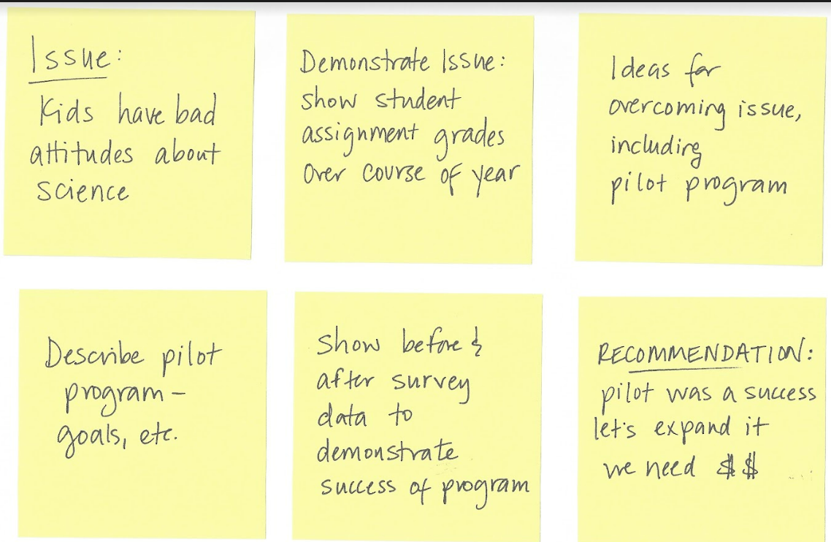

Consider a project where you need to create and explanatory communication, like a slide deck. Get a stack of sticky notes and a pen. Find a quiet workspace you can inhabit for about 30 minutes with a large empty table or whiteboard. Tackle the following.

**BRAINSTORM.** Set a timer for 10 minutes. Start the timer and see how many ideas you can get out of your head and onto stickies. You can imagine that each small square reflects a piece of potential content in your eventual deck. That said, don't filter your thoughts—rather, let it be a cathartic process (there are no bad ideas during this step). Don't worry about order or how the ideas fit together at this point in the process. Simply see how many sticky notes you can fill up in a set amount of time.

*Tip:* do this low-tech exercise after you have spent enough time with the data to know what you want to communicate with it, but before you start creating content with your computer. This exercise is best done after you've created, solicited feedback on, and refined the Big Idea for a given project.

**EDIT.** The ideas are out of your head in writing on sticky notes—now it's time to edit and organize them. Step back and think about what overarching structure can help you tie everything together in a way that will make sense to someone else. It may be helpful to make additional stickies for meta topics or themes as you organize your ideas. Where can you group things together? What might you eliminate?

Speaking of eliminating, start a discard pile. For each sticky note you consider, ask yourself: does this help me get my Big Idea across? If you can't come up with a good reason to include it, move it to the discard pile.

Here are some specific questions to contemplate as you're determining what order works best for your situation:

* How will you present to your audience: are you there live, over the phone or through a webinar, or sending something out that will be consumed on its own?
* What order will work well for getting your content across to your audience? Does it make sense to start with the action you want from them, build up to it, or something in between?
* What context is essential? Does your audience need to know it up front, or does it better fir later? How quickly should you answer "So what?"
* Do you already have established credibility with your audience, or do you need to build it? If so, how will you do that?
* Were assumptions made in your work? When and how should you introduce those? What if your assumptions are wrong? Does that materially change the message?
* Do you need input from your audience? How and where can you best get that?
* At what point does data fit in? Does the data confirm expectations or run counter to them? What data or examples will you integrate and where?
* How can you best create common ground, get buy-in, and prompt action?

There is no single right path, but the answers to the preceding questions will help you think through different options that could work well for your given circumstance. If there is non-message impacting data or other content that you can't bear to get rid of, push it to the back—either physically by putting it later in the document (perhaps in the appendix) or visually by de-emphasizing it and putting emphasis on the most important components of what you need to communicate.

**SEEK FEEDBACK.** After creating your storyboard, talk through it with someone else. There are a couple benefits to this. First, simply talking through it can be helpful. Doing so forces you to articulate your thought process, which can help illuminate alternate approaches. Second, sharing with someone else may introduce new perspectives or ideas that help you improve your storyboard. Iterate given what you've learned from this process. Remember to obtain stakeholder or manager feedback at this point. This can be a great early check-in point to get confirmation that you're on the right track, or redirect your efforts—before you've invested a ton of time.

[Modified from the book Storytelling with Data, Knaflic, 2019](https://community.storytellingwithdata.com/exercises/the-big-idea-for-your-project)